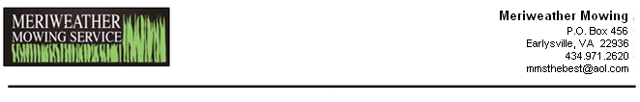

Dear [CustomerFirstName]:

With a stormy spring in our rearview mirrors, we now look ahead to all the fun chores summer has in store. So load up on the Calamine lotion, Coppertone, and Off…..or…..just let us do the work while you “work” on lowering your handicap.

Below is a list of seasonal jobs you might need help with; we checked off the ones we’ve done for you in summers past. If you need an estimate on a particular item, we’ll be happy to drop by and give you one. Don’t worry, there’s no obligation. If you see something you like, call us at 971-2620 or email MMSthebest@aol.com, otherwise just put it in your “Information Of The Utmost Importance” file.

[ServicesCommentHeader]
[PropertyListSummerServices]

Have other needs? We also do the following Services:
[RemainderListSummerServices]

Also, for those who have been walloped by recent harsh weather, keep in mind that we clean up storm damage (we’ve got a chipper and several dump trucks), and clean gutters (high winds can fill gutters with all sorts of debris in a hurry).

Sincerely,

Dave & Rod

